Wrike Artist Process SOP
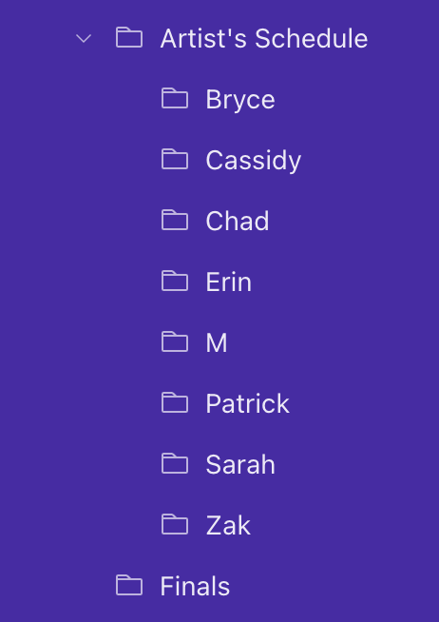
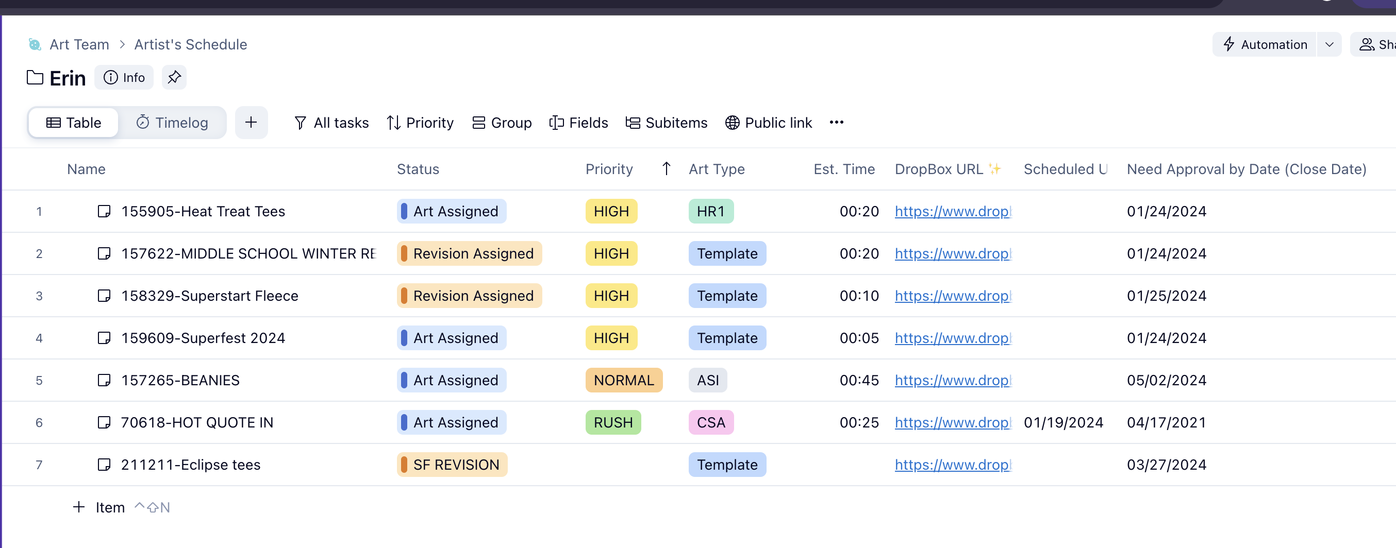
- Artist Dashboard and Starting Artwork

1.Look for your folder under Artist Schedule folder
2. Your dashboard will look like image above. Make sure your tasks are set to All tasks.
3. Start your artwork as usual by changing status to In Progress.
(Make sure you press In Progress every time. Otherwise we won’t be able to properly upload artwork.)

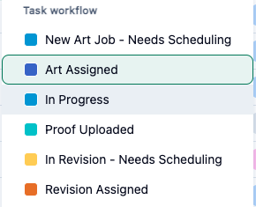
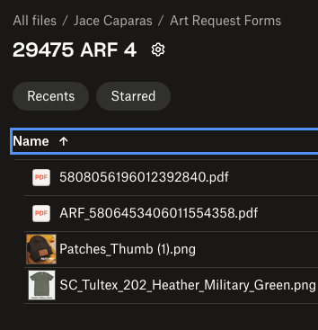
4. Press Dropbox URL field to go to the opportunity house. This Dropbox folder will contain the ARF pdf and any CSAs supplied.

5. Open ARF pdf. If there are two ARFs, open the one starting with ARF_

6. Once you are done with your art and get approval from your peers. We will upload.

2. Uploading
1. Open the Opportunity Ticket in WRIKE.
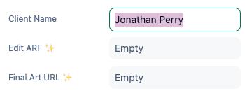
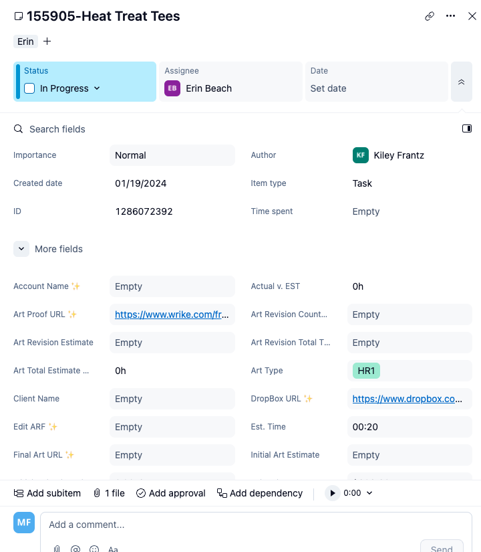
2. Copy Client Name in the Ticket

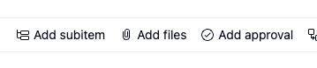
3. Press Add Files and select your proofs

4. Select your proofs and press Start Guest Review
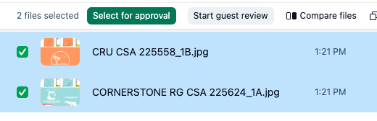

5. A window will Pop up.
•Add email approver@sundaycool.com.
•Add Client Name
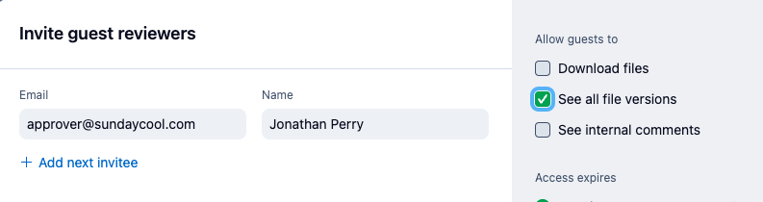
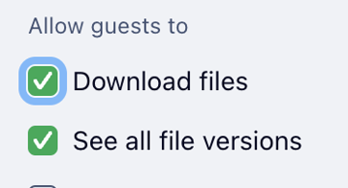
•Select See All File Versions
6. Press Invite. Once you press Invite, your Status will automatically change to Uploaded, and move off of your schedule to the Uploaded folder.

3. Revisions
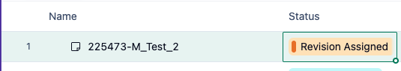
- Revisions will appear as Revision Assigned or SF Revision. Change Status to Revision in Progress

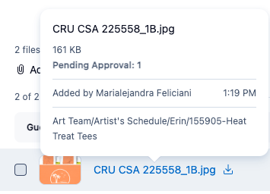
2. Go to the Opportunity Ticket and press on the image link as shown below. Proofs with revisions will show Changes Required

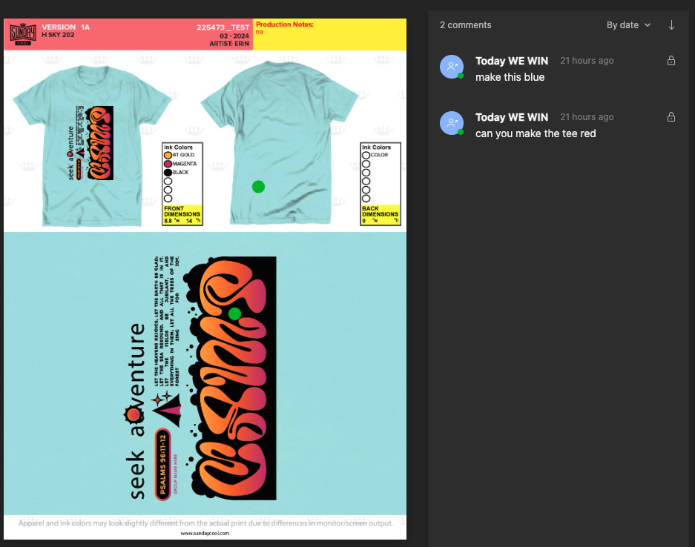
3. Client or PA will leave revision notes in the Wrike Portal as shown below.
4. Complete your revision and get approval from peers.
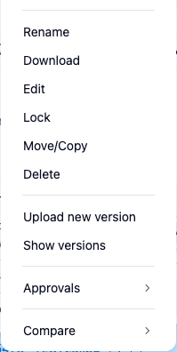
5. Right click over image link, and select Upload New Version
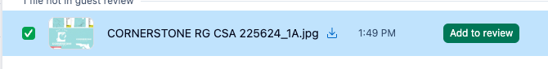
If you have multiple revision proofs. Add files and Select button Add to Review

zz

Multiple Files, Add To Review
6. Change Status to Revision Uploaded

